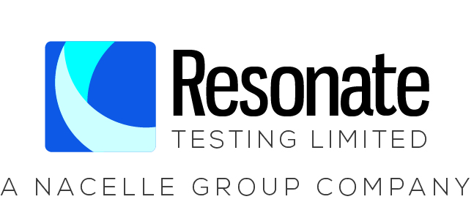

JOB DESCRIPTION

Resonate Testing, based in Newry, Northern Ireland, is an award-winning commercial test house for organisations in need of high-quality testing and certification services. A wholly owned subsidiary of The Nacelle Group, Resonate Testing specialises in fire and flammability, vibration and shock, environmental and climatic, packaging, ingress protection and bespoke testing processes.
The company operates across a wide range of sectors including aerospace, automotive, oil and gas, medical devices, consumer goods, telecommunications and more recently has been making headlines for its work within the space sector.
Resonate Testing operates a purpose-built facility that has been declared a Centre of Excellence. It is the only commercial facility on the island of Ireland that can perform combined temperature and vibration testing.
Due to continued growth, the company is recruiting a TECHNICIAN to join its team.
Job Title: Technician

Start date: November 2022

Reporting To: Chief Technician

Salary Range £22,000 to £28,000 GBP
Job Purpose: Ultimately, Resonate Testing’s role is to provide customers with a range of testing to demonstrate compliance with international performance standards supporting safety or reliability of their products. The Resonate Testing brand is recognised for its ease to work with, consistency in approach and accuracy of results when carrying out an expanding portfolio of high-tech tests for a range of prime customers and industries globally.
The successful candidate will work in our mechanical and environmental test facilities.
An essential requirement of this role is logical thinking, working under one’s own initiative and having an awareness of the sector and testing processes.
Full training and support will be given to the successful candidate to develop them in the role and help the company continue our business growth.
The role will be varied, and daily tasks will include working with, and in compliance with, the requirements of our Quality System, including regular internal auditing of workspace.
We are looking for an individual capable of working flexibly to meet the changing demands of a busy test facility. The role is focused towards test equipment preparation and conducting tests. The job is a 'hands on’ role requiring the completion of multiple manual activities. You will need to have good 'attention to detail’ and be capable of maintaining a disciplined and consistent approach to all testing activities within the facility, be a good communicator and team player.
Note: Applicants must have all appropriate permits and visas to work in the European Union.
The successful candidate will be asked to complete an AccessNI check

Key Responsibilities:

- Preparation of parts and material samples for both internal testing and for despatch to external testing as required including measuring samples, identification marking, packaging for transport and inventory control
- Identification and installation of relevant test fixtures and instrumentation and its set up ready to conduct test
- Instrument test pieces and operate internal equipment used in data acquisition systems for data collection (Training provided)
- Follow and document appropriate test procedures
- Populate standard report information
- Maintain testing equipment and keep testing space organized, clean and safe
- Manage inventory of consumable test supplies
- Read and learn test standards and procedures to ensure correct application of test methodology (Training provided)
- Ensuring safe working practices and following safety guidelines and procedures, observe all safety operating procedures and ensure the use or correct PPE
- Learn the correct use of equipment and follow best practice and internal procedures
- Learn and adhere to internal quality policy, working with quality in mind and reporting any deviations through the Quality process

PERSON SPECIFICATION

Job Title: Technician

Criteria | Essential / Desirable
Qualifications/ Attainments | Essential Requirement  - A relevant technical or engineering qualification  - Good level of written and numerical / data handling skills  Desirable Requirement  - Fabrication, welding, and electrical installation experience.  - Previously working within a technician role and quality system.
Relevant Knowledge and Experience | Essential Requirement  - Interest in technical subjects  - Ability to operate and maintain a wide variety of hand and power tools  Desirable Requirement  - Experience in dealing with quality system documentation  - Familiarity with the software languages and tools used in automated test solutions (i.e. National Instruments LabView etc.)  - Familiarity and use of SolidWorks as a design and fabrication aid.
Skills and Competencies | Essential Requirements  - Ability to follow oral and written instructions and interpret technical instructions.  - Able to learn new information and maintain confidentiality  - Excellent interpersonal skills  - Ability to work autonomously to drive towards business targets  - Extensive Experience with MS office tools (Outlook/Excel/Word/PowerPoint)
Circumstances | Essential Requirements  - Able to work flexibly as required to ensure business needs are met  - Able to manage own workload and priorities  - Full valid driving license  - Willingness to undergo any further training to meet the needs of the company.  Desirable Requirements  - Forklift licence

